Special General Meeting of the
GERMAN SHEPHERD DOG COUNCIL OF AUSTRALIA Inc.
to be held on Friday 24th July 2015
at “Comfort Inn Haven Marina”,
6 – 10 Adelphi Terrace, Glenelg North, South Australia.

A G E N D A

Notice of Special General Meeting

To be held on Friday 24th July 2015, commencing at 1.00pm to 5.00pm.

To discuss the following :

GSDCA “Draft” Social Media Code of Conduct

GSDCA Code of Ethics - Amendments
- GSDCA Breed Improvement Schemes – 3.2
- GSDCA Breed Survey Results – 3.7

GSDCA Restructure “A Way Ahead”

“DRAFT” GSDCA Social Media Code of Conduct

Background

Social media has become an integral part of day to day communication for individuals as well as businesses.

Social media is defined as the social interaction among people in which they create, share or exchange information and ideas in virtual communities and networks.

Social media may include but is not limited to magazines, Internet forums, weblogs, social blogs, microblogging, wikis, social networks, podcasts, photographs or pictures, video, rating and social bookmarking. Technologies include blogging, picture-sharing, vlogs, wall-posting, music-sharing, crowdsourcing and voice over IP.

Its ability to capture community sentiment and shape opinions is driven by its dynamic and immediate nature.

What constitutes ethical behaviour can be somewhat ambiguous when engaging in social forums, however the GSDCA believes it’s Officers, Member Clubs and their members should uphold the highest ethical standards demonstrating respect, honesty and integrity when engaging with one another.

This Social Media Code of Conduct aims to provide guidelines on best practice behaviour when using social media.

Guidelines

- Abide by GSDCA Guiding Principles & Code of Ethics
- Be reasonable and respectful – do not post malicious, misleading or unfair content in relation to Officers, Member Clubs & their members or members of other ANKC affiliated bodies.
- Be accurate – any comment posted as fact should be able to be substantiated
- Act in manner that is consistent with good community expectations

The same values that apply in the real world also apply in the virtual world and in social media exchanges.

Despite the seemingly unregulated nature of social media, the law still pertains online. Postings online (and similarly in email or text messages) are subject to the law in areas such as defamation, sexual abuse, racial discrimination, intimidation and bullying.

Breach of the Social Media Code of Conduct

The GSDCA and through its Member Clubs continually monitors activity in relation to the organisation.

GSDCA takes compliance with this policy seriously. Detected breaches of the policy should be reported to GSDCA in first instance and then matter sent to Member Clubs for investigation.

A breach of this Code may result in disciplinary action which could result in, but is not limited to, the issuing of a formal warning or suspension.

The GSDCA will not tolerate, condone or support any posting it considers could be damaging to children. Such offences will be automatically referred to Police for action.

NOTE: matters relating to sexual abuse, racial discrimination, intimidation and or bullying may be referred for legal opinion or to Police.

Consultation or advice

This policy has been developed to provide guidance for GSDCA Officers, Member Clubs and their members

Any Officer or member of a Member Club who are unsure of their rights, liabilities or actions online can seek clarification from Secretary, GSDCA or the Secretary of the Member Club they are a member of.

GSDCA Code of Ethics - Current

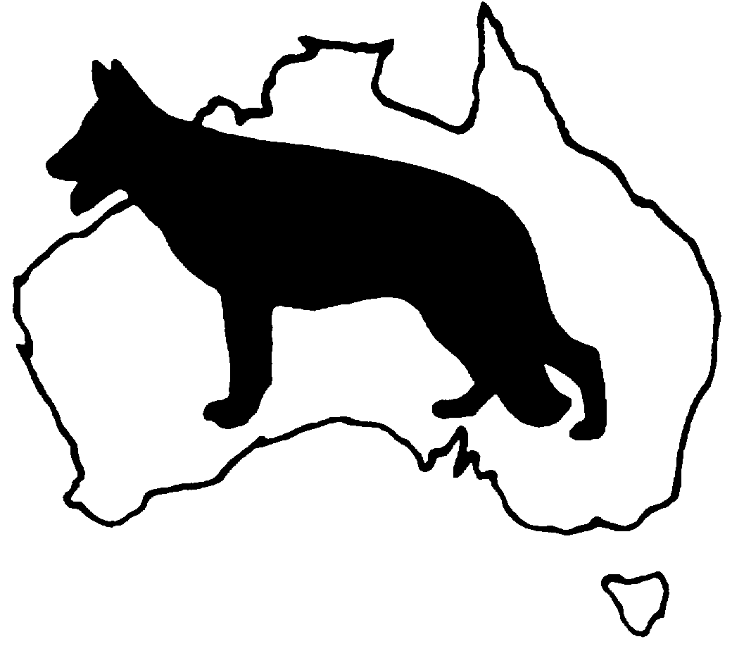 | GERMAN SHEPHERD DOG COUNCIL OF AUSTRALIA  Code of Ethics for Members Clubs and Officers of Council

As a Member Club and or Officer of the GSDCA will :

- Support the objectives of the Council.

- Encourage our Members, as owners and breeders of the German Shepherd Dog, shall ensure that all dogs under their care are properly and appropriately cared for.

- Encourage our Members as breeders of German Shepherd Dogs :

      - Comply with ANKC and State Canine Control “Codes of Ethics” as they apply;
      - Will only breed with animals that are ANKC registered, German Shepherd Dogs;
      - Will as per ANKC ruling only breed with a bitch that is 18 plus months of age;
      - Will as per ANKC Ruling only offer at stud a dog that is 18 plus months of age;
      - Understand that as per ANKC ruling a bitch may be bred on two successive occasions if in good health, but must be rested for 12 months after the second litter;
      - Will ensure that at least the sire of the litter is successfully breed surveyed;”
      - Will not allow puppies to leave their care before 8 weeks of age;
      - Will vaccinate all puppies for Distemper, Parvovirus, and Hepatitis by 8 weeks (normally done at 6 weeks) of age and prior to leaving my premises;
      - Must as per ANKC ruling microchip the whole litter prior to leaving the kennels;
      - The whole litter may also be tattooed under the GSDCA Tattoo scheme at 6-8 weeks of age and prior to leaving members care;
      - Ensure that the whole litter is registered with the ANKC on either the Main or Limited register and that both varieties are correctly registered as such;
      - Members will supply each purchaser of their puppies with :

        - literature regarding the raising, caring and training of German Shepherd Dogs;
        - information relating to Member Club contacts in State or Territory of domicile of purchaser;
        - information relating to the GSDCA Breed Improvement Schemes;
        - a 5 generation pedigree;
        - an ANKC registration certificate for the puppy as sold;
        - an individual certificate of vaccination for the puppy as sold;
        - ensure the puppy is healthy at the time of leaving the members care.

- Will not sell puppies through pet shops and/or weekend markets.

GSDCA Code of Ethics – (Proposed Amendments)

GERMAN SHEPHERD DOG COUNCIL OF AUSTRALIA

Code of Ethics for Members Clubs and Officers of Council

As a Member Club and or Officer of the GSDCA I/we will :

- Support the objectives of the Council.

- Encourage our Members, as owners and breeders of the German Shepherd Dog, shall to ensure that all dogs under their care are properly and appropriately cared for.

- Encourage our Members as breeders of German Shepherd Dogs :

      - To comply with ANKC and State Canine Control “Codes of Ethics” as they apply;
      - To Will only breed with animals that are ANKC registered, German Shepherd Dogs;
      - To Will as per ANKC ruling only breed with a bitch that is 18 plus months of age
(as per ANKC ruling);
      - To Will as per ANKC Ruling only offer at stud a dog that is 18 plus months of age
(as per ANKC ruling);
      - Understand that as per ANKC ruling a bitch may be bred on two successive occasions if in good health, but must be rested for 12 months after the second litter
(as per ANKC ruling);
      - To Will ensure that at least the sire of the litter is successfully breed surveyed;”
      - To Will not allow puppies to leave their care before 8 weeks of age;
      - To Will vaccinate all puppies for Distemper, Parvovirus, and Hepatitis by 8 weeks (normally done at 6 weeks) of age and prior to leaving my premises;
      - To Must as per ANKC ruling microchip the whole litter prior to leaving the kennels
(as per ANKC ruling);
      - That the whole litter may also be tattooed under the GSDCA Tattoo scheme at 6-8 weeks of age and prior to leaving members care;
      - To ensure that the whole litter is registered with the ANKC on either the Main or Limited register and that both varieties are correctly registered as such;
      - To Members will supply each purchaser of their puppies with :

        - literature regarding the raising, caring and training of German Shepherd Dogs;
        - information relating to Member Club contacts in State or Territory of domicile of purchaser;
        - information relating to the GSDCA Breed Improvement Schemes;
        - a 5 generation pedigree;
        - an ANKC registration certificate for the puppy as sold;
        - an individual certificate of vaccination for the puppy as sold;
        - ensure the puppy is healthy at the time of leaving the members care.

- Will not sell puppies through pet shops and/or weekend markets.

- Officers of the GSDCA will comply with the GSDCA Social Media Code of Conduct.

3 GSDCA BREED IMPROVEMENT SCHEMES
3.2 Positive Identification
3.2.2 Microchipping
3.2.2.2 Acceptance of Microchips for GSDCA Breed Improvement Schemes

3.2.2.2.3 FOR NEW ZEALAND BRED ANIMALS

Current regulation
New Zealand (NZ) bred dogs must still be identified by a tattoo controlled through the NZ German Shepherd Dog Advisory Council (NZGSDAC) system, and the tattoo is verified by the NZGSDAC.
At this stage Microchips will NOT be accepted for New Zealand (NZ) bred dogs.

Proposed Amendment
New Zealand (NZ) bred dogs must be identified by a tattoo controlled through the NZ German Shepherd Dog Advisory Council (NZGSDAC) system, or by Microchip and the tattoo and or microchip is verified by the NZGSDAC.

Rationale:
New Zealand through the Kennel Club have compulsory microchipping for all pedigree animals.
Moved South Australia

3.7 GSDCA Breed Survey Results
Current Regulation

3.7.3 Both the grading and millimetres of change are to be shown on both the breed survey certificate and on the GSDCA Database. [2015]

Proposed Amendment
    - Both the grading and millimetres of change for the GSDCA ED Control Scheme are to be shown on both the breed survey certificate and on the GSDCA Database.
For overseas animals only the overall grading will be shown.

Moved: South Australia

GSDCA Restructure: - A Way Ahead.
“That the GSDCA further discuss the restructure model as drafted at the SGM held on 6 February 2015 and make recommendations with regard to proceeding with the restructure of Council.”
Moved: President, GSDCA

Double click to open file

Prior to the holding of the 2015 GSDCA AGM a Special General Meeting was held to discuss what the ‘NEXT STEP” with regard to discussion as held and outcomes that arose from the GSDCA Future Directions” Workshop” as held in 2012.

As President, I offered a model as a starting point in order to stimulate discussion prior to the meeting. This initial presentation acted as a catalyst that saw another two slightly amended models presented by fellow Executive members: Jane Pike and Val Moody.
There was much discussion with regard to how best place the Council for the future and with the models as presented the process of reviewing GSDCA Executive and other positions took place. The meeting ended with what was a positive feeling for changes as proposed in the attachment to go forward and be reviewed by the Member Clubs with their input to be put forward at a SGM to be held prior to the NBC/ Judges Meeting in July 2015.
I again ask the Member Clubs to openly discuss this matter and provide their input. This meeting will decide on whether or not Council will take the ‘next step’ and if the model as presented requires further shaping and the timeline for the change to be made.
It must be noted that a full rewrite of the GSDCA Constitution will accompany any motion to change the management structure of the council.

